USE OF CONTRAST AGENTS TO ENHANCE IMAGE QUALITY IN 2 D ECHOCARDIOGRAPHY FOR STRAIN ANALYSIS
I. Baig¹, S. Nanavaty², A. Sothwal², A. Alsaid, T. Bauch¹
¹University, Geisinger Medical Center, Danville, PA, USA
²University, Wright Medical Center, Danville, PA, USA

Objective: Cardio-Oncology is a growing field. Many of these patients have suboptimal ultrasound imaging windows that may preclude accurate assessment of GLS. Ultrasound contrast agents enhance image quality but have not been validated.
Methods: Standard resting views were acquired before and after Definity (perfluten, Lantheus Medical Imaging) contrast injection as part of our standard TTE echo protocol using a Philips iE33 machine. pre- and post-contrast apical views were selected and GLS analysis performed with Qlab version 10.3 and a preset strain quality threshold of 40. Global longitudinal strain analysis was performed both with and without contrast agents. A Bland- Atlman scatter plot was used to delineate these findings. Mean and standard deviation for difference in each individual chambers finding were also noted as below.
Results: Twenty-four patient exams were analyzed, with mean age 54 +-14, and 42% were men. Longitudinal strain was obtained in all apical segments both pre- and post-contrast for all subjects. Average values for each view and for GLS are shown in Table 1. A Bland-Altman plot (Figure 1) displays the range of agreement between pre- and post-contrast measurements across the set of measured GLS. Our analysis reproduced the encouraging findings. Our results need to be validated in larger studies.
Clinical Implications: If ultimately validated, this could greatly expand the utility of echocardiography for early detection of ventricular dysfunction in vulnerable populations
A. Table 1 – Average Values for Longitudinal Strain from each apical view, and Global (GLS), with (+) and without (-) contrast
 | Mean (SD) |  | Mean (SD) |  | Mean (SD) |  | Mean (SD)
GLS(+) | -20.3(2.7) | AP2(+) | -20.0(4.1) | AP3(+) | -22.4(4.0) | AP4(+) | -18.4(3.1)
GLS(-) | -21.4(3.9) | AP2(-) | -22.2(4.3) | AP3(-) | -20.2(5.3) | AP4(-) | -21.6(4.2)
Difference | -1.1(4.0) |  | -2.2(4.3) |  | 2.2(6.3) |  | 3.2(4.2)
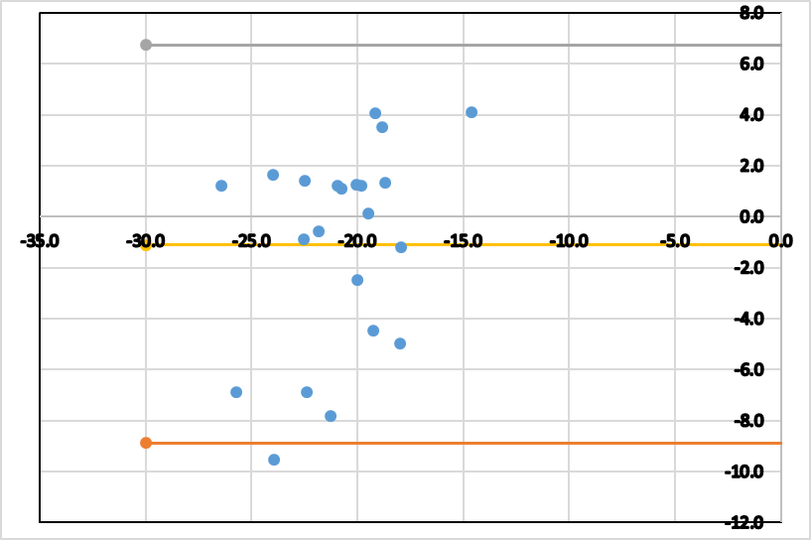
Figure 1 – Bland-Altman plot of average GLS (x-axis) versus the difference between pre- and post-contrast GLS

